Configuring and Passing Parameters

Parameter Files

Parameters are used for the following:
- Place holders for tags or parts of a tag
- Change Communication Path
- Tag Substitution
- Reusable Displays

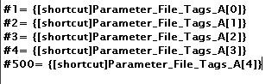

- Parameter Files will define parameters that will be used.
- Place Holder (#) are assigned tag name or a value within Parameter Files
- Each Place Holder is assigned a unique numeric value from 1 to 500

Parameters can be assigned to various Objects:

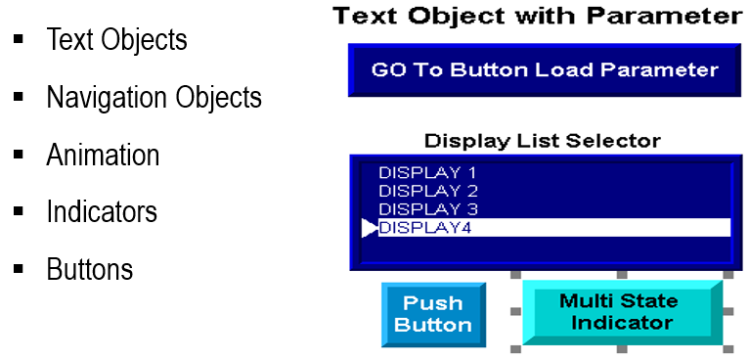
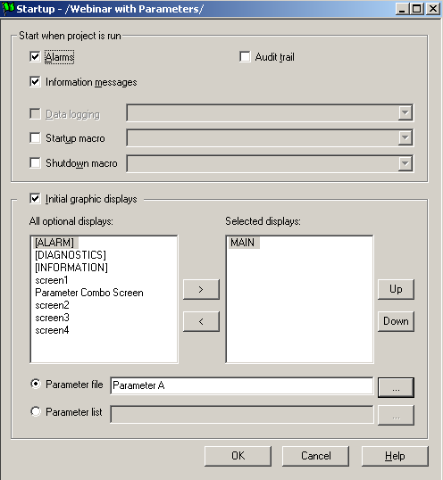
Loading a parameter file can be achieved by the following:
- GoTo Display Buttons
- Display List Selector
- Start Up of Application
- Global Connections

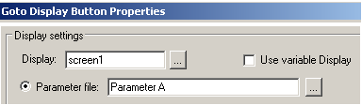

Parameter List

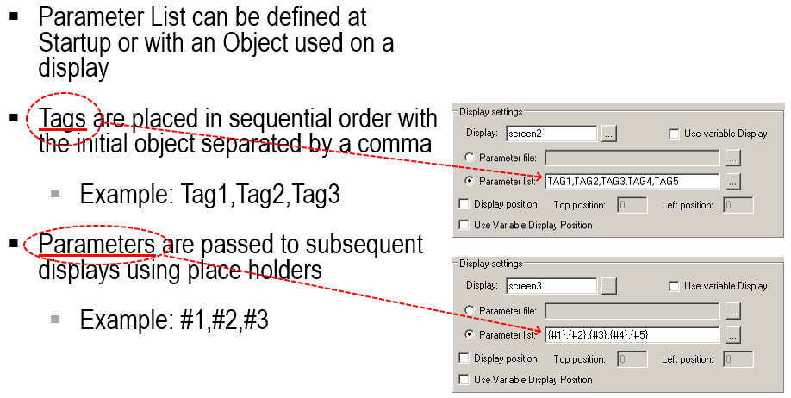

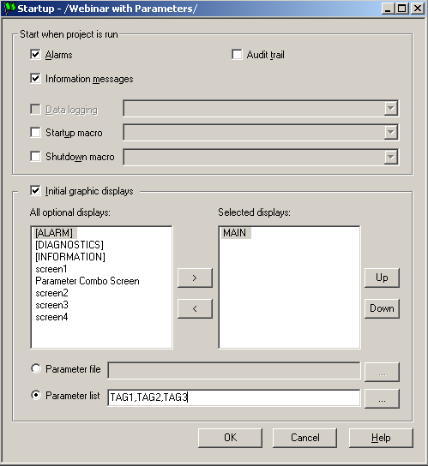
- The Parameter List is configured the same way in the Startup menu as it’s configured for display navigation objects
- In this example parameter tags are loaded to the main startup screen

- Place holders within the navigation objects will forward the parameters to other screens

Global Connections
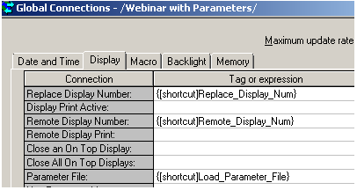
- Parameters can be used when the displays are controlled remotely

- Parameter File and Parameter List tag fields are also located in the Display tab of Global Connections

- The Parameter File tag field in the Global Connections requires a string data type

- Operators could manually type
the parameter file name or the
process can be automated
through the PLC

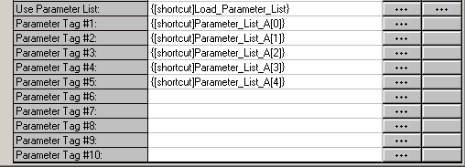
- Parameter List can also be used within Global Connections
  - Note: The Parameter List is limited to 10 place holders

- The Use Parameter List field must be enabled with a digital tag prior to loading the list

Global Objects

To access the Global Object Parameter Definitions, right click on the object or group of objects on the Global Object Display | Paste the object on the active display (non- Global Object Display), right click again and select Global Object Parameter Values
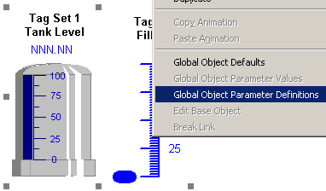 | 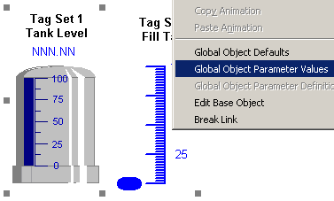

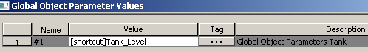

- The parameter place holder will appear in the Name column of the Global Object Parameter Values properties
- The Value column is where tags or parts of the tag are entered for the place holder
- The image shows #1 used for the tag called “Tank_Level”. This tag could be a User Define Tag (UDT) or Add On Instruction (AOI) type
- Members of the UDT tag are added to the Connections tab of each Global Object member

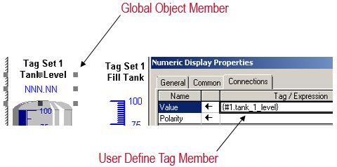

- When passing parameters through Global Object you must be careful of the syntax
- UDT members assigned to the Global Object member can cause errors if not addressed properly
  - Example: {#1.tank_1_level} is assigned to the Global Object member, and [shortcut]Tank_Level is assigned to the place holder #1
- The period before tank_1_level could have been assigned in the #1 place holder. This will still work, however, other members of the Global Object will fail if the format is not consistent

The same place holder can be defined for more than one Global Object and copied to the same display.

The place holder #1  is defined as [shortcut]Tank_Level | The place holder #1  is defined as [shortcut2]Tank_Level2
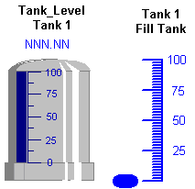 | 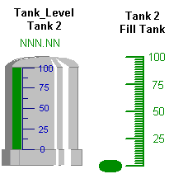

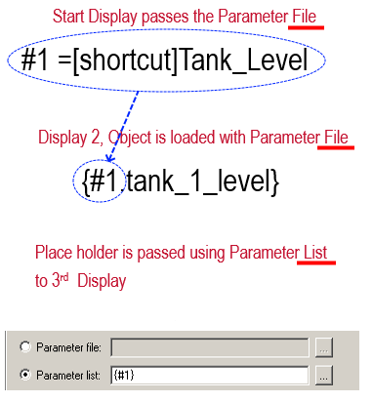
Combining Parameter Methods

Parameter files can be combined with Parameter List, for example:

- Parameter file can be loaded to a second display with a Go To button

- The data can then be pass to a third display using a Parameter List

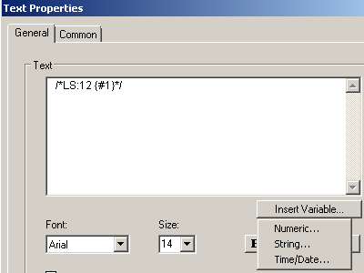

- Text objects with literal String and Numbers can be passed in a parameter

  - Example: In the text properties select the Insert Variable and decide if the value will be String or Numeric

- Based on that decision the Literal String or Literal Number option is available
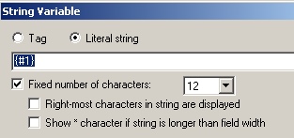
- Insert in the Parameter place holder (e.g. #1)

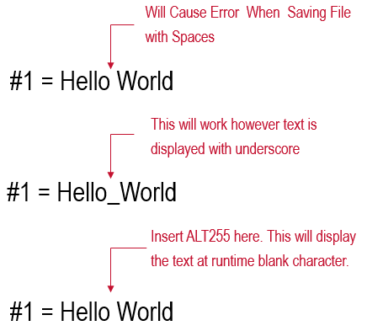

When using a parameter file with a Literal Text object spaces between text will result in an error when trying to save.

There are two options to resolve this:
- Insert an Underscore as a separation between words

- Pressing ALT and entering 255 inserts a blank ASCII extended character between words to add separation

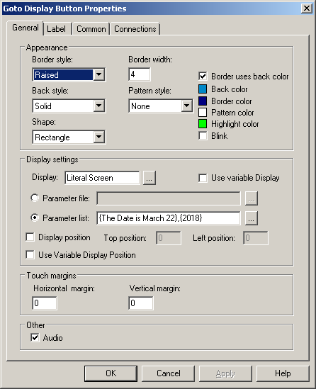
Combining Parameter Methods

Parameter List can also pass parameters to Literal Strings or Numbers.

The example shows two sets of text used for the parameter list

{The Date is March 22},{2018}

#1 and #2 will be the place holders used on the destination screen

#1 is a text object using Literal String
#2 is a text object using Literal Number

ALT255 was inserted to create the spaces between words.

Using parameters within arrays
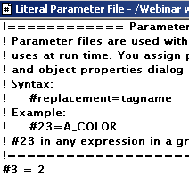

Parameter place holders can be used to point to a specific word of the array.

In the example #3 is equal to a numerical value of the array.

Tags with the numerical value cannot be used.

{[shortcut]Parameter_File_Tags_A[#3]}

